Name: Ritika Mohan
Prn: 23070521183
Semester: 5th C (C1)
Aim: Functions, Scope & Error Handling:
Create and invoke functions using declarations, expressions, and arrow syntax. Explore scope and closures. Include try-catch blocks to handle input errors. Write a function to reverse a number and check for palindrome.
Output:
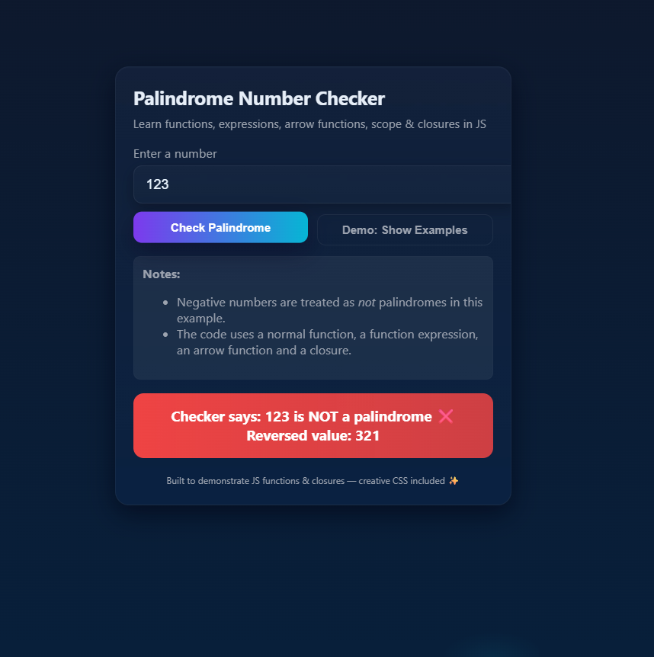
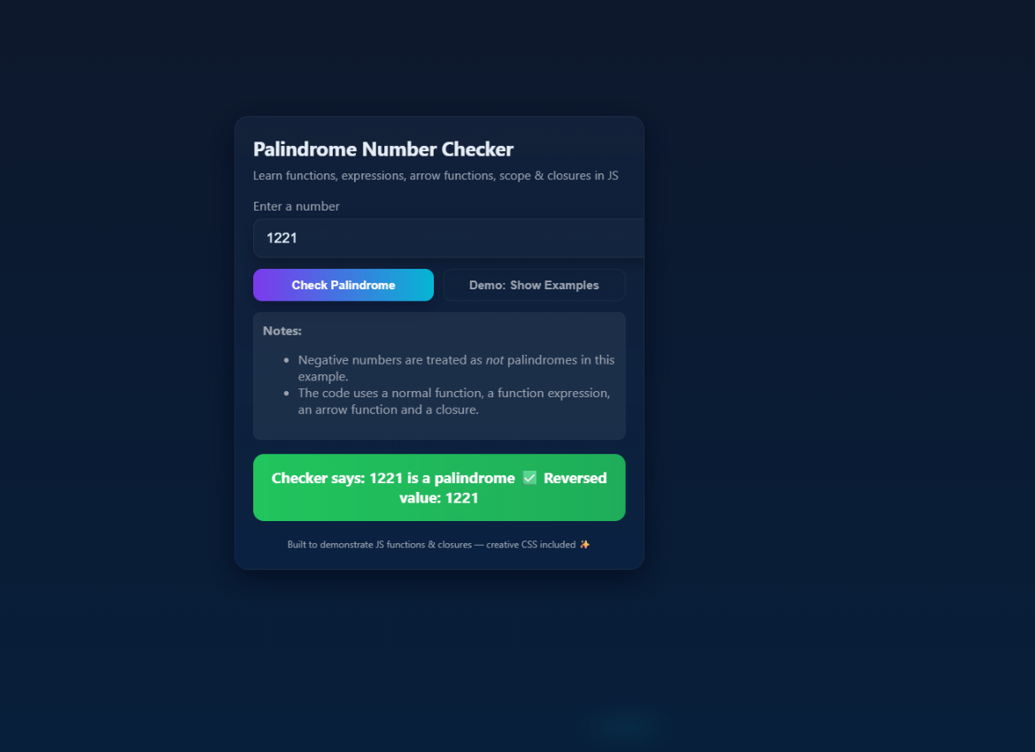
Theory
- A function is a block of code designed to perform a particular task.
- Functions help in reusability, modularity, and better readability of code.
Types of Functions
- Function Declaration (Normal function):
Declared using the function keyword.
Example: function reverseNumber(num) { ... }
- Function Expression:
A function stored inside a variable.
Example: const isPalindrome = function(num) { ... };
- Arrow Function:
Shorter syntax, introduced in ES6.
Example: const formatMessage = (num, ok) => { ... };
Scope
- Refers to the accessibility of variables.
- Global scope: Accessible everywhere.
- Local scope: Accessible only inside a function.

Closure
- A closure is created when an inner function remembers variables from its outer function even after the outer function has finished execution.
Case Study
- Function reverseNumber() is used to reverse a number.
- Function isPalindrome() checks if the number equals its reverse.
- A closure is used to customize messages.

Conclusion: Written a function to reverse a given number and used this function to check
whether a number is a palindrome or not.

